pop the pig  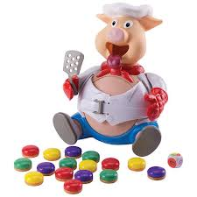  Basic Level  Ages: Pre-K- 5th grade | Pieces included in visuals  Rules for game  - Have the student roll the dice  - Once the student rolls the dice, have them select the color that they rolled from the pile of hamburgers  - Using the visuals, have the student tell the group what color they rolled and what number, using the sentence strip  - Place the hamburger in the pigs’ mouth, and push the head down based on the number printed on the hamburger  - Play until the pig’s belly pops out  Additional Tips and Ideas  - Give a peer all the hamburgers, and have the student request a hamburger from the peer  - Have peers help the student push down on the pig’s head if needed

